**TEST PLAN for Trello**

# **Introduction**

Trello is one of the leading project management apps currently available on the market which has a score of 9.8 and has won our **Best Project Management Software Award for 2018**. Trello utilizes the concept of boards ( which correspond to projects) and within boards, there are cards (which represent tasks). The cards contain lists which can be used to track the progress of a project or to simply categorize things. Well-integrated and reasonably priced.

# **Objectives**

Our main objective from this test plan is to cover the most important bullet points to find bugs and then be able to solve it later on.

The main Ideas to test for will be covered later.

**Team members**

Only me for now. :”D

# **Scope**

The initial phase will include all ‘must have’ requirements. These and any other requirements that get included must all be tested. At the end of Phase 1, We must be able to:

1. Create a manual test with as many steps as necessary

2. Save it

3. Retrieve it and have the ability to view it when running the test

4. Enter results and appropriate comments

5. View results

During our work on the product using this test plan, we will discover phase two which may include:

* Load testing.
* Rewriting, moving or porting existing test cases.

Here’s an example of what we’re going to work on: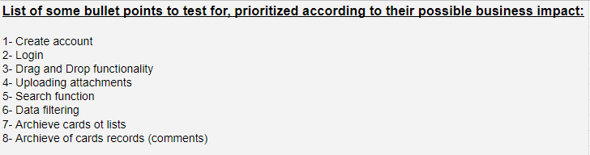

Note: You can access test cases for some of these bullet points through this [sheet](https://docs.google.com/spreadsheets/d/1lnwqiMEr_7bzoB5sUxq-AcFsgo6BXxpw71PwZn7xxas/edit?usp=sharing).

# **Risks**

# There is a risk that we might be unable to finish the testing process before a delivery of a milestone, although we should avoid this from the very beginning but if that happened then, at this time we will focus on the impact (severity/ priority) of the un-tested part to make a decision whether to postpone the deadline of delivering the whole product or reschedule a deadline for the unfinished part.

# **Test Approach**

The project is using an agile approach, with bi-weekly iterations. At the end of each iteration the requirements identified for that iteration will be delivered to the team and will be tested.

## **Test Automation**

Automation test will cover only the basic and stable features within each iteration, If a feature will be changed in a sprint or two. Automation test won’t be applied.

Note: There are missing sections on this test plan as there’s no need for them at this challenge so I skipped them.